UNU-IRADDA Setup – D1

Area | Module | Activity | Migration Requested | Accomplished Via
Configuration | Purchasing | Location | Y | DMS
Configuration | Purchasing | Ship To Location | Y | DMS
Configuration | Purchasing | PO BU Definition | Y | DMS
Configuration | Purchasing | Contract and Vendor Rebate Controls | Y | DMS
Configuration | Grants | Institution | Y | DMS
Configuration | Grants | Grants Department Definition | N | Manual Setup in D1/T1/S1 & P1
Configuration | Payables | AP BU Definition | Y | DMS
Configuration | Payables | AP BU Options | Y | DMS
Configuration | ChartFields | Operating Unit | N | Manual Setup in D1/T1/S1 & P1
Configuration | ChartFields | Budget/Expenditure Department | N | SAS will help configure Depts in P1  D1/T1 & S1 Manual Setup
Configuration | TableSet Setup | TableSet ID/Control | Y | DMS
Configuration | Tree Setup | GL/KK Trees for UNU - Dept and Project | N | Manual Setup in D1/T1/S1 & P1
Configuration | ChartFields | Combo Build for UNUNI ONLY | N | Manual One-Time run in all environments
Configuration | Security | New Permission List | N | Manual Setup by Atlas Security Team in all environments
Configuration | Security | BU Security | Y | SQL Insert scripts
Configuration | ARGUS | New Country Setup for UNUNI | N | Manual Setup by Atlas Security Team in all environments
Configuration | ARGUS | New Budget Department Setup | N | Manual Setup by Atlas Security Team in all environments
Configuration | Workflow | Route Control Profile - UN_BU_UNU_ALL | Y | DMS
Configuration | Accounting Periods | Open Period Setup | N | Manual Setup in D1/T1/S1 & P1

Location | Location Definition
Navigation:  Set up Financials/Supply Chain > Common Definitions > Location > Location  Add a new location  SetID – UNUNI  Location Code – 623  Address:  University of Algiers 1 (Benyoucef Benkhadda)  2 rue Didouche Mourad  Algiers  16000  ALGERIA/DZA | 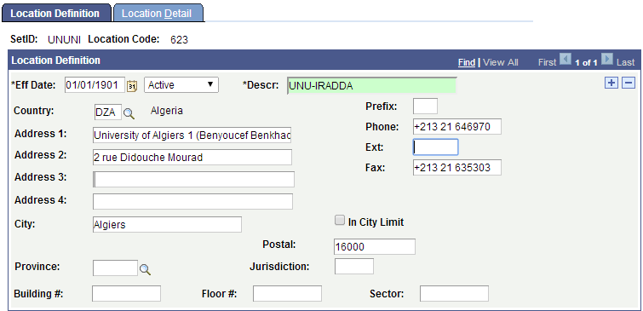  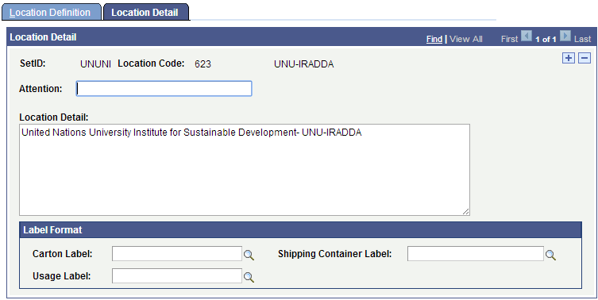

Ship To Location | Ship To Locations Definition
Navigation:  Set up Financials/Supply Chain > Product Related > Procurement Options > Purchasing > Ship To Locations  Add a new Ship To Location  SetID – UNUNI  Ship To Location = 623  Change Region SETID to SHARE  Change Receiving Business Unit to 623UU* | 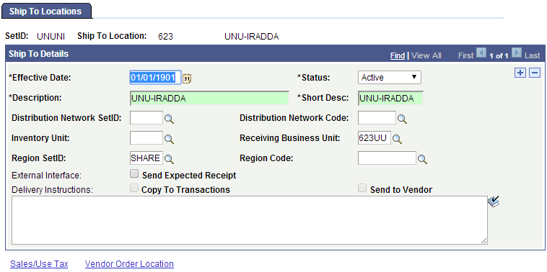  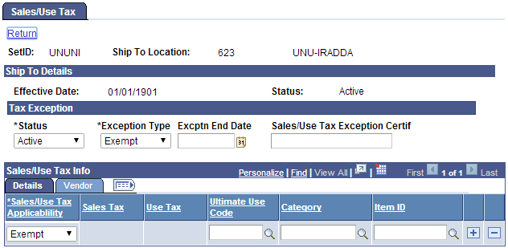  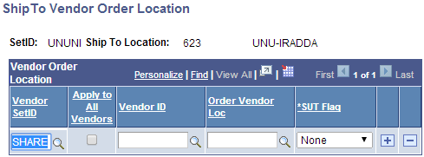

Grants - Institutions | Institution Definition
Navigation:  Grants > Institutions > General Information  Create a new Institution 623 | 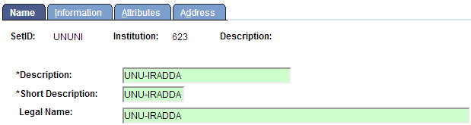  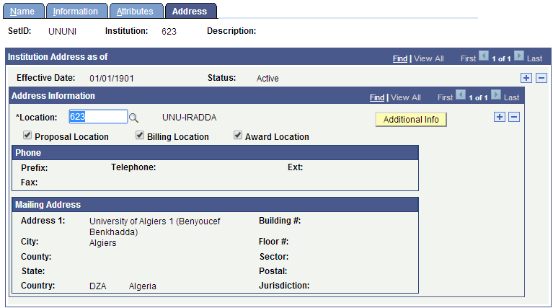

Payables | AP BU Definition
Navigation:  Set up Financials/Supply Chain > Business Unit Related > Payables > Payables Definition  Create a new AP BU 623UU  ***Uncheck “Post Unapproved Vouchers”  ***Uncheck “Post Unmatched Vouchers” | 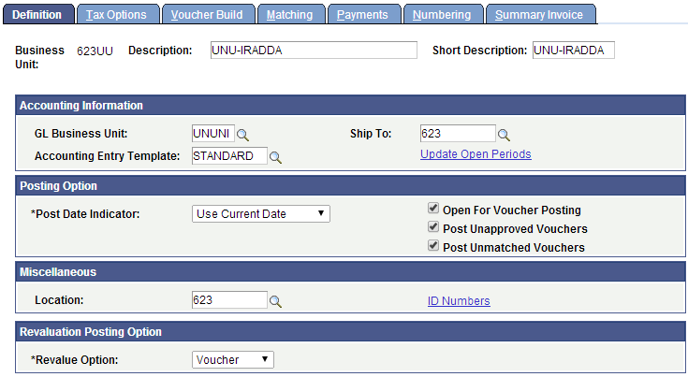  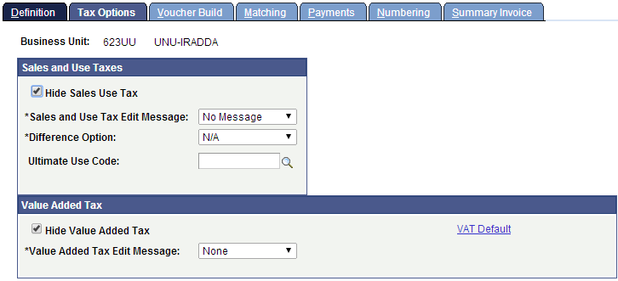  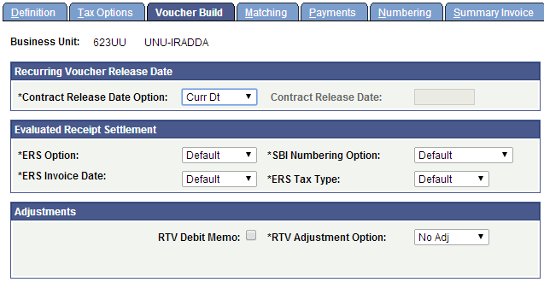
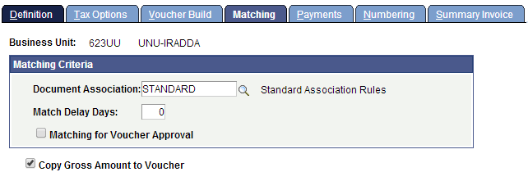
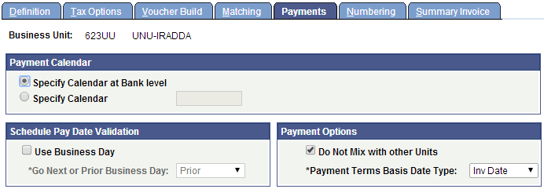
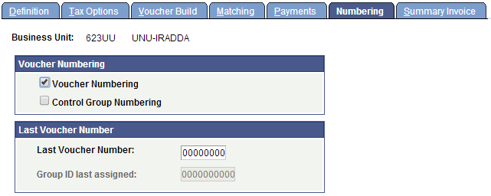
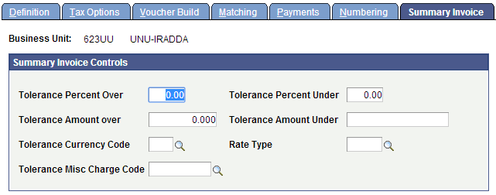
Navigation:  Set up Financials/Supply Chain > Business Unit Related > Payables > Payables Options  Setup UNU-IRADDA Payables Options | 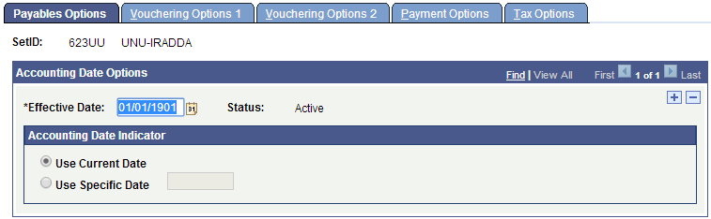  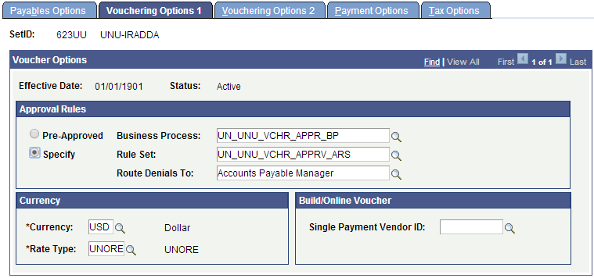  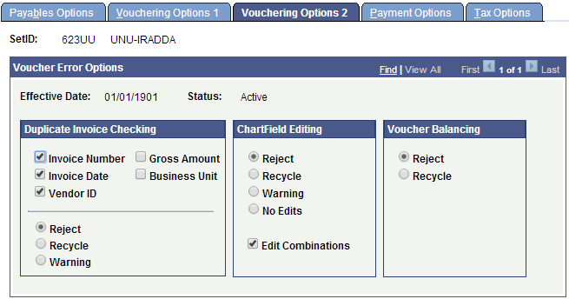

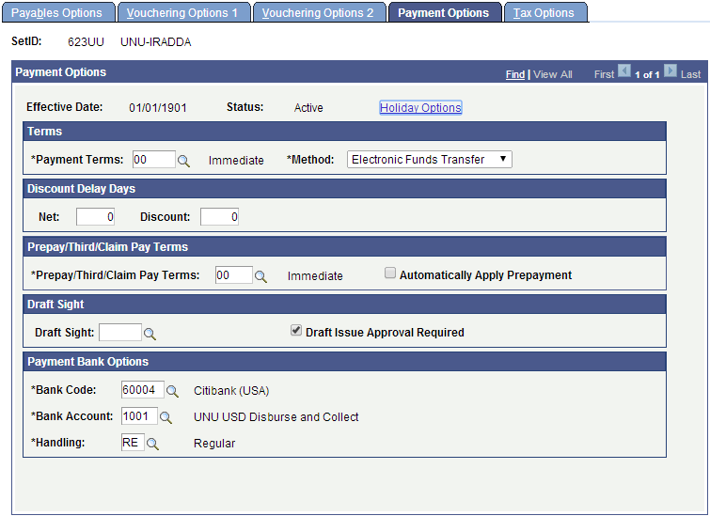
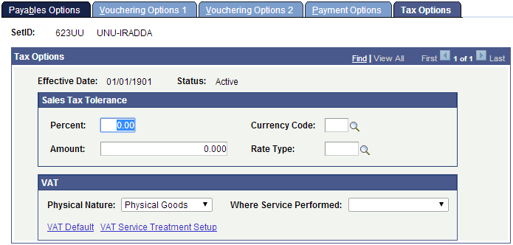

Purchasing | PO BU Definition
Navigation:  Set up Financials/Supply Chain > Business Unit Related > Purchasing > Purchasing Definition  Add a new PO BU – 623UU | 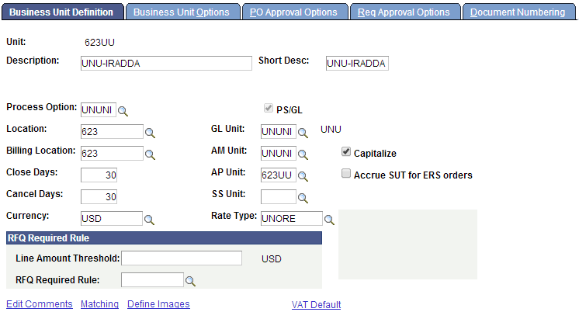  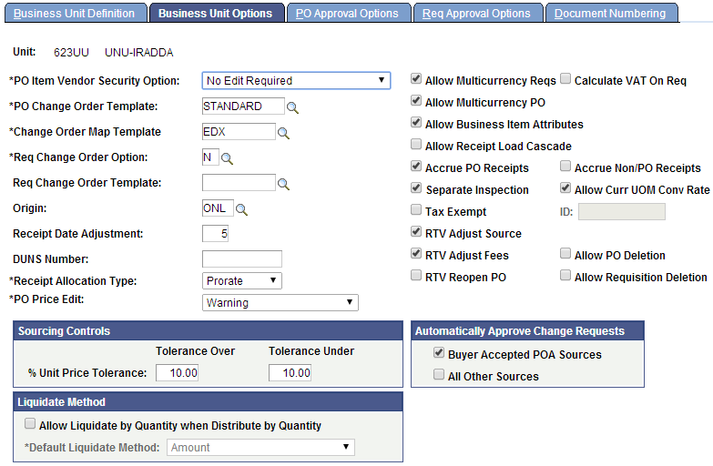
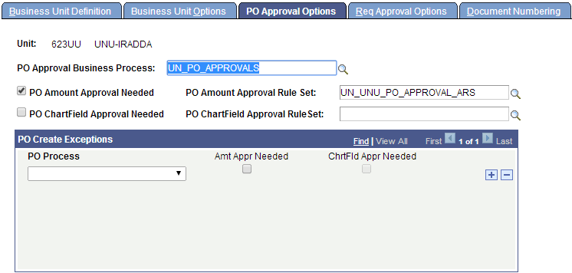
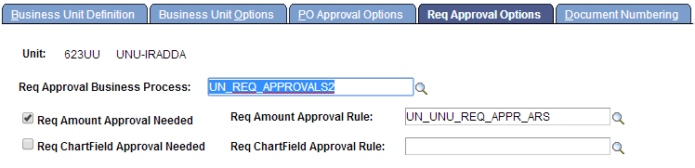
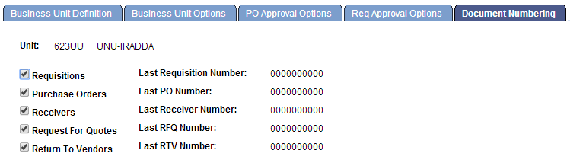

Procurement Contracts | Contract and Vendor Rebate Controls
Navigation:  Set up Financials/Supply Chain > Product Related > Procurement Options > Purchasing > Set Controls-Contracts  Add a row for new SetID 623UU | 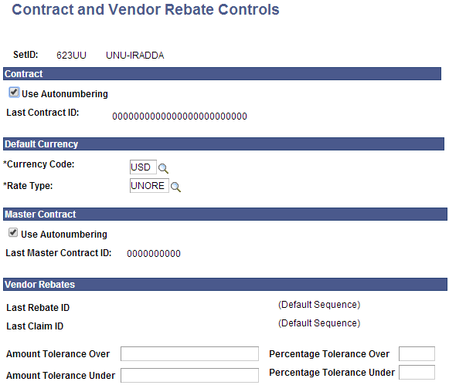

ChartFields | CF Definition
Navigation:  Set up Financials/Supply Chain > Common Definitions > Design ChartFields > Define Values > ChartField Values > Operating Unit | 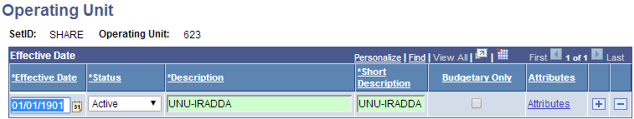  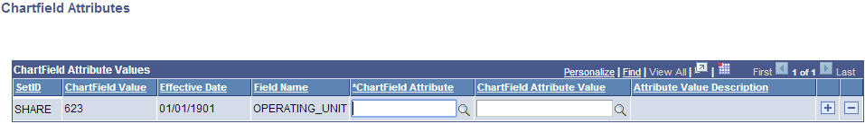
Navigation:  Set up Financials/Supply Chain > Common Definitions > Design ChartFields > Define Values > ChartField Values > Department  Add Department B0780 & 78001*  - As per current procedure(s), these departments would be setup by SAS in HCM and then they will be synced. Ensure that B0780 has the “Budgetary Only” check box checked. | 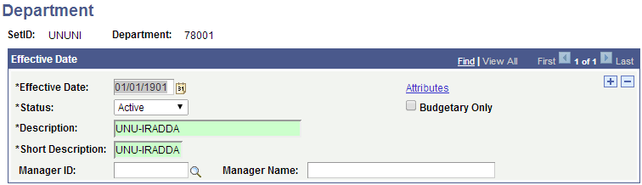  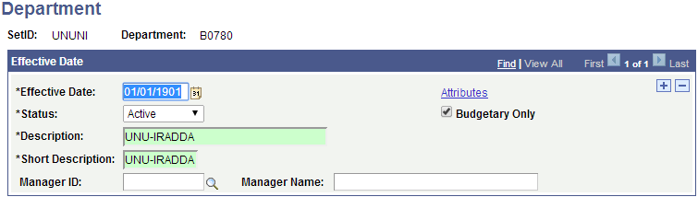

Grants - Departments | Grants/Department Definition
Navigation:  Grants > Departments > General Information  Search for Budget Department B0780 | 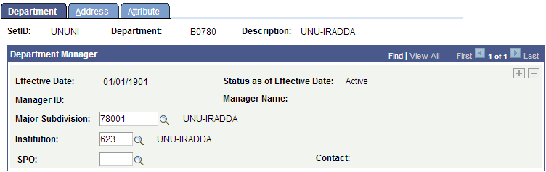  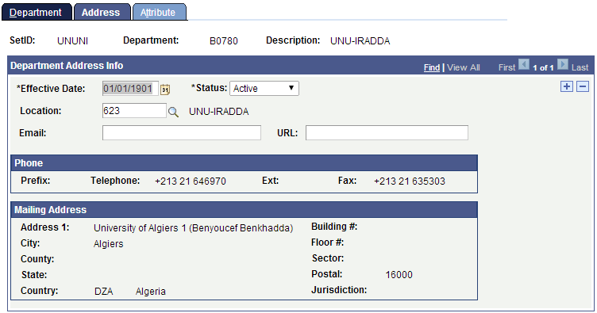  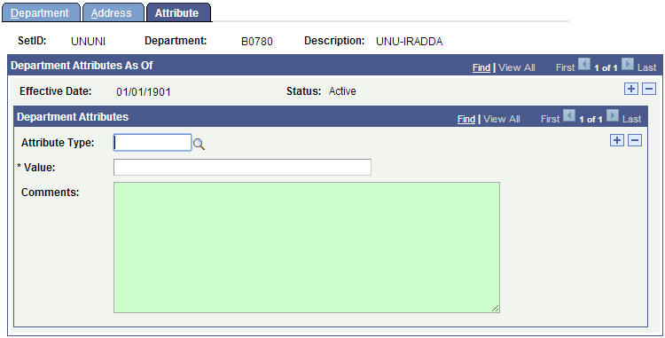

TableSet ID | TableSet ID Definition
Navigation:  PeopleTools > Utilities > Administration > TableSet IDs  SetID – 623UU | 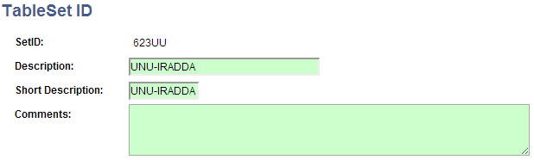

TableSet Control | TableSet Control Definition
Navigation:  PeopleTools > Utilities > Administration > TableSet Control  Set Control Value – 623UU | 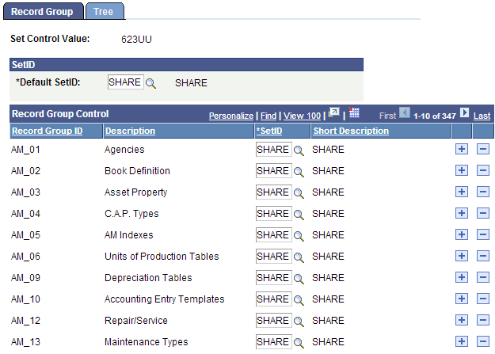

Tree Setup | CC_UNUNI_DEPT
Navigation:  Tree Manager > Tree Manager  Open Tree CC_UNUNI_DEPT/01/01/2010  Add Budget Department B0780, and specify the range – 78001 to 78099 | 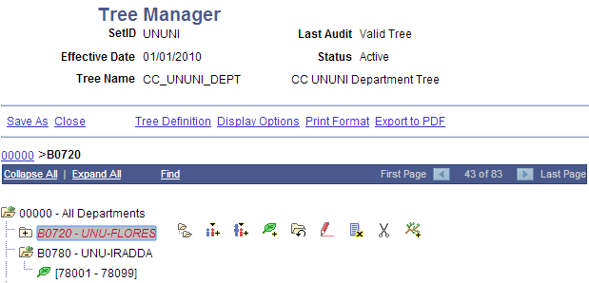

Tree Setup | DEPT_ROLLUP_UNUNI
Navigation:  Tree Manager > Tree Manager  Open Tree DEPT_ROLLUP_UNUNI/01/01/2010  Add new Tree Node 623 (UNU-IRADDA/01/01/1901), and specify the following range(s)  - 78001 to 78099  - B0780 – UNU-IRADDA | 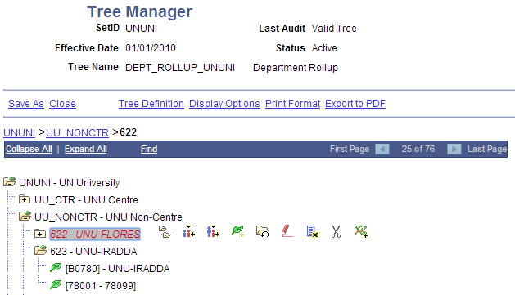

COMBO Build for UNU ONLY | Build Combination Data Request
Navigation:  Set Up Financials/Supply Chain > Common Definitions > Design ChartFields > Combination Editing > Build Combination Data  Note the options selected  Run for BU UNUNI and Ledger Group ACTUALS | 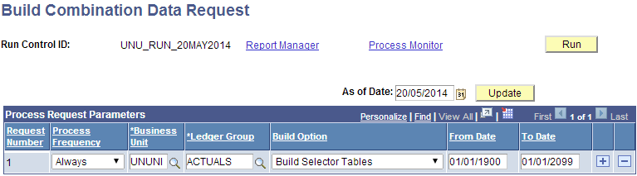

Permission List | PPL - 623
Navigation:  PeopleTools > Security > Permissions & Roles > Permission Lists  Create new Permission List 623UU | 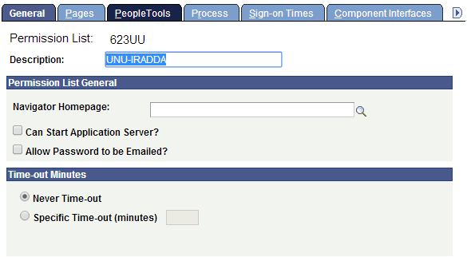

Permission List | Unit By Permission List
Navigation:  Set Up Financial/Supply Chain > Security > Unit by Permission List  Add 623UU to 600UU and ALLPAGES PPL’s.  This is for TESTING purposes ONLY.  Rows will be inserted by SQL. | 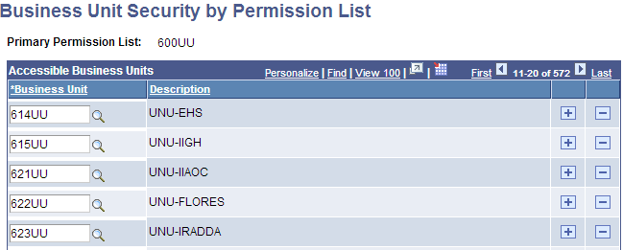  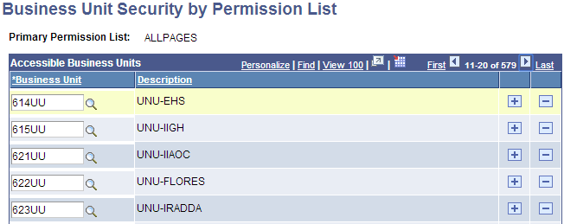

Permission List | Unit By Permission List
Navigation:  Set Up Financial/Supply Chain > Security > Unit by Permission List  Check PPL 623UU  --Row Level Security for 623UU  INSERT INTO PS_SEC_BU_CLS  SELECT '623UU' , BUSINESS_UNIT FROM PS_BUS_UNIT_TBL_FS;  INSERT INTO PS_SEC_BU_CLS  SELECT DISTINCT(OPRCLASS), '623UU' FROM PS_SEC_BU_CLS WHERE OPRCLASS NOT LIKE 'EA%'  AND OPRCLASS NOT IN (SELECT OPRCLASS FROM PS_SEC_BU_CLS WHERE BUSINESS_UNIT = '623UU'); | 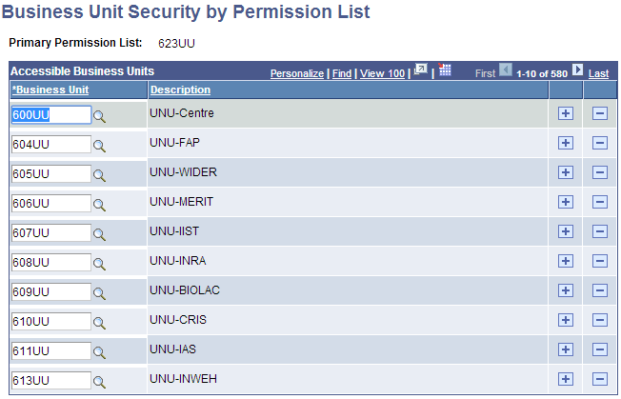

ARGUS | Setup
Navigation:
UNKNOWN

--ARGUS
INSERT INTO PS_UN_BU_USERPREF VALUES ('UNUNI', 'DZA', '623UU', 'UNU-IRADDA', 'UNU-IRADDA');
--1 Row

XNODE/XPRGM Setup | Grants
Navigation:  Grants > Awards > Project  Create new XNODE for 623 (UNU-IRADDA) as per naming convention – UU623A  Create new XPRGM (s) UU623A01 & UU623AZZ | 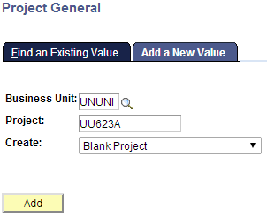  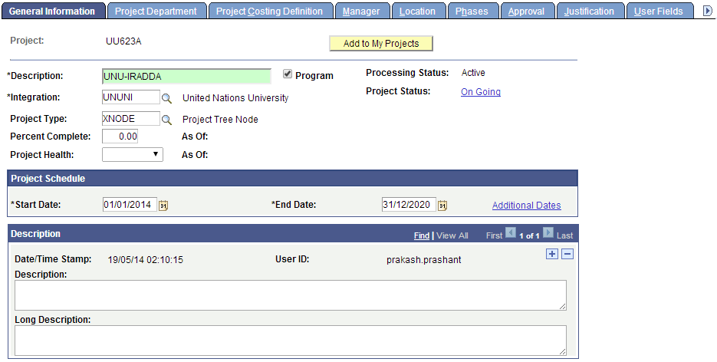  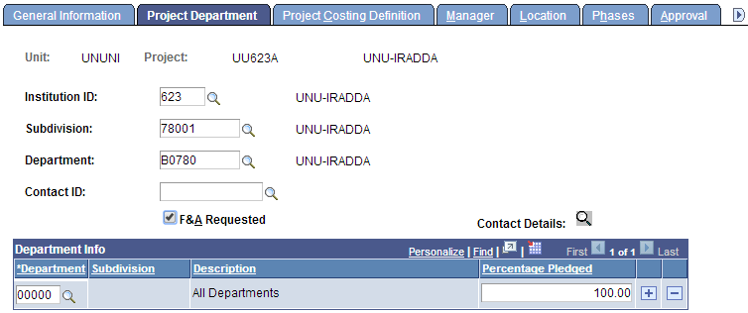
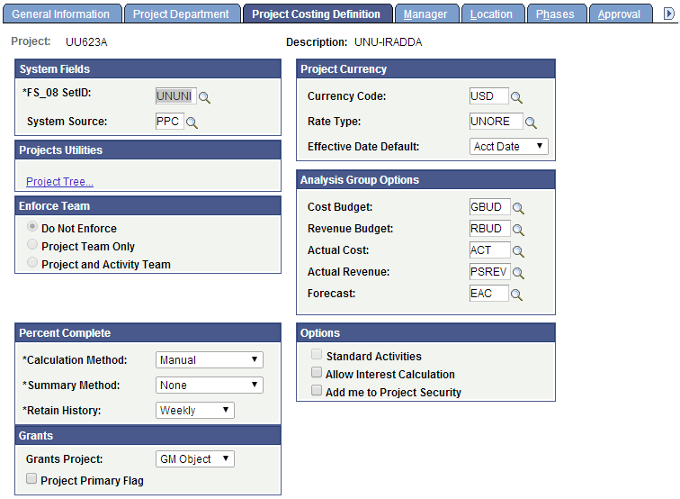
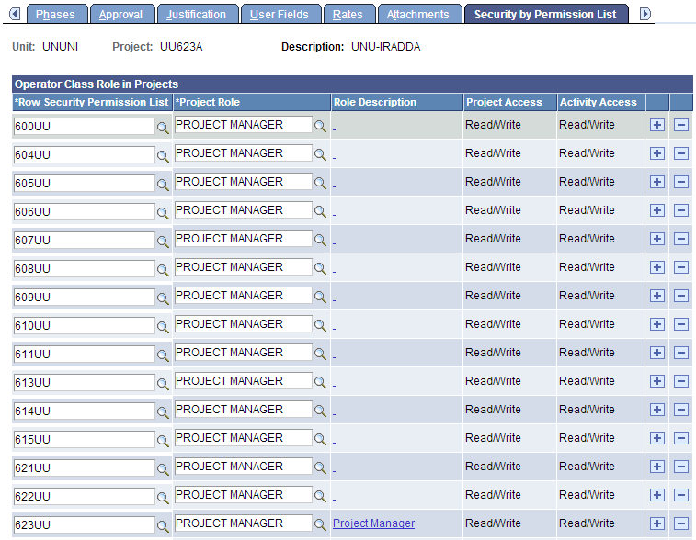
Create Program UU623A01/XPRGM  Business would have to create these manually in production | 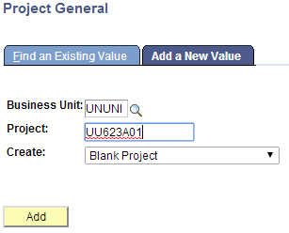  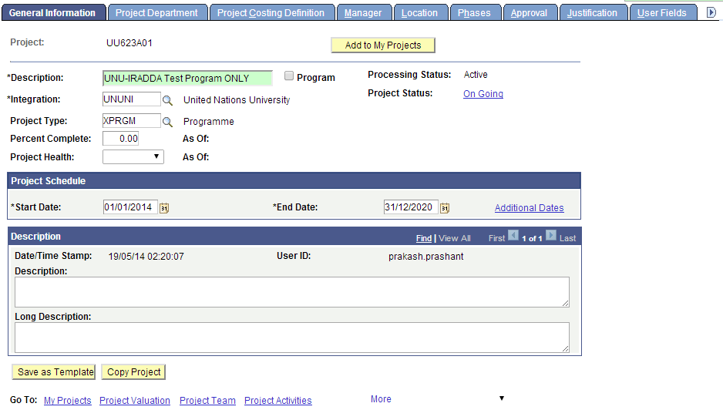  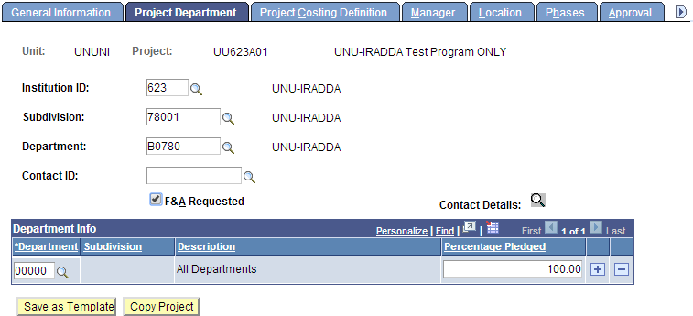
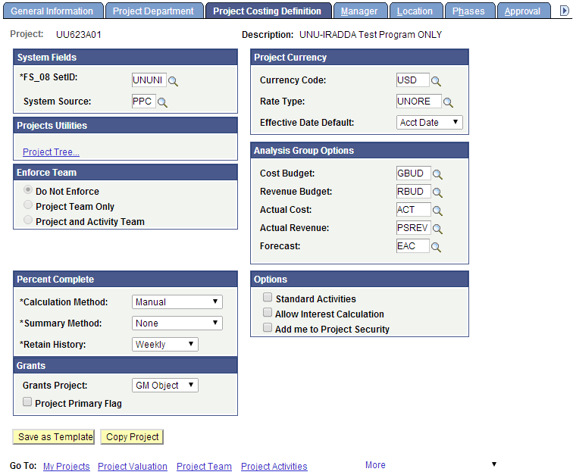
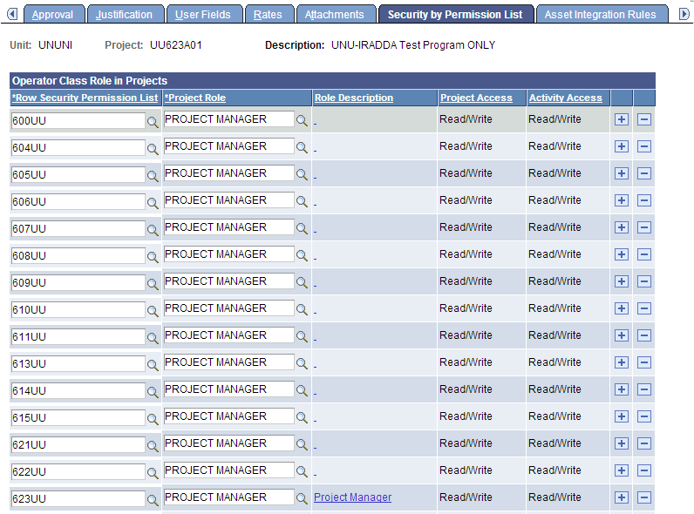

Tree Setup | UNU_PROGRAMME
Navigation:  Tree Manager > Tree Manager  Open Tree UNU_PROGRAMME/01/01/2010  Add the XNODE/XPRGM(s) for UNU-IRADDA 623 | 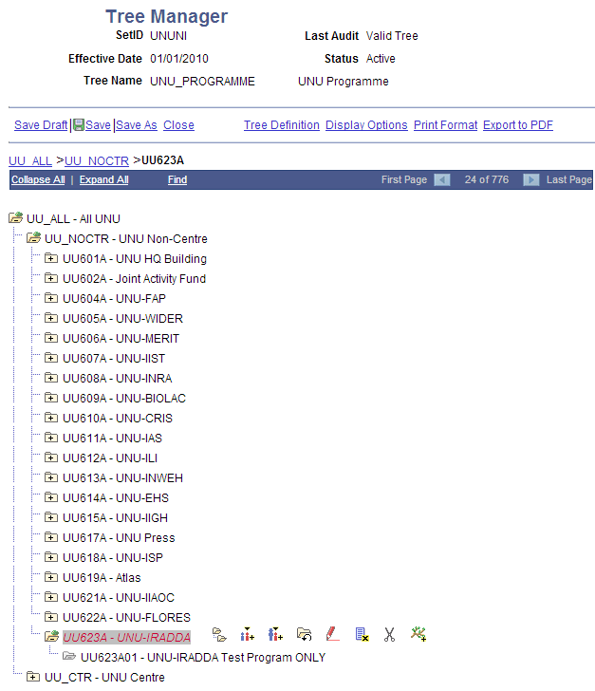

Workflow | Route Control Profiles
Navigation:  PeopleTools > Workflow > Routings & Roles > Route Control Profiles  Search for Route Control Profile – UN_BU_UNU_ALL  Add 623UU to profile.  It would be ideal to create Route Control Profiles for each BU, as that would help limit current AO access to their own AP/PO BUs. | 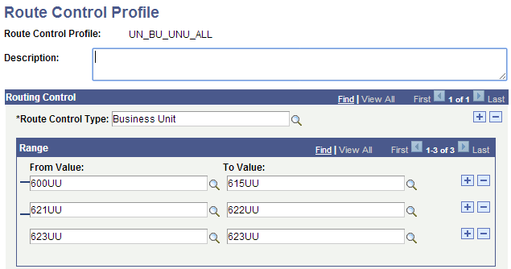

Open Periods | Open Period Update - AP
Navigation:  Set Up Financials/Supply Chain > Business Unit Related > General Ledger > Open Periods > Open Period Update  KL will set this up manually in Production.  This has been in D1 for testing purposes ONLY. | 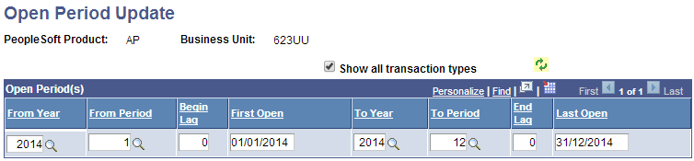

AP Voucher Bank Defaults | CUSTOMIZATION
Navigation:
UN Custom > Treasury > UN Voucher Bank Default

Check from AP team on the Bank Default

SELECT * FROM PS_BANK_ACCT_CHRT WHERE BANK_CD LIKE '6%';
SELECT * FROM PSXLATITEM WHERE FIELDNAME IN ('BANK_ACCT_LED_TYPE', 'BANK_ACCT_TYPE');

PS – Only Payables Cash Checking Bank Accounts are allowed

